

**Hong Kong Institute of Vocational Education (Sha Tin)**

Department of Information Technology

Higher Diploma in Mobile Applications Development

ITP4207 Emerging Technology in Mobile Computing

**Project Title:**

**IOS Report**

|  |
| --- |
| **Class:** IT 114112 / Year 2 / 2A  **Leader:** 170063248 Ngai Yiu Lik  **Member:** 170231389 Chiu Ka Yau  170146681 Chen XuChu  170234889 Lau Man Kit  **Contact Person:** Ngai Yiu Lik, Leader,  **Supervisors:** Kwok Yu Ho    **Date:** 16/5/2019  **Version:** 1 |

Content

**Introduction** **3**

**Background** **3**

**Requirement specification** **4**

**Functional Requirement** **4**

**Storyboard** **6**

**Structure of database tables** **7**

**User Guide run(Capture screen)** **8**

**Function** **8**

**Conclusion and Further development** **15**

**References** **16**

# Introduction

Nowadays, people care about their health and weight problems. Before people enjoy food, they will worry about the calorie of the food or how much sugar the food has. For manage weight, peoples always eat low calorie or sugar-free food. So, we develop the app of Food Intake Recorder as a reminder to keep a record of his/her food intake.

Many people don’t know how much they need to absorb so that they cannot control their health problem caused by overweight. In order to help weight management, the apps provide an intake suggestion.

# Background

Local or foreign food nutrition data, calorie consumption calculations, etc., the purpose of the app help users establish and maintain a healthy lifestyle and diet, so the effectively control weight is very important. the application will be Calendar form design to record the data, Our database integrates the nutritional information of common foods such as egg yolks, fish meat, bowls, chicken tails, and clam cakes. The user can enter the food name or other to calculate the calories and main nutrients. ingredient. it is easy to use. But, the user must register an account which includes their personal information in order to the secret problem and accurate calculation. Users only need to enter personal data such as height, weight, and daily diet to assess their weight status and calculate the daily calories required. Besides, we also provide the share function, the user post the data to Facebook, Email, WhatsApp etc. In the other hands, the users can record voice note if they don’t want to type, it is convenience for the lazy people

# **Requirement specification**

# Functional Requirement

Account

* **Register**

Public user need provides their username,password to register to be customer,which can convenient

**Login**

User can save their record and record their amount of exercise

* **Single Login**

When the users log in the system. The user should not enter data again in the next time. It simplifying the process of the user login

* **Edit Account data**

User view the data wrong, they edit the account data to be corrected.

Add Data

* **Record voice note**

The voice record provides other choice to store the related food information, if the customer don’t want type the data. they can use the voice record function to record the record of speaking.

* **Table Way**

The user can type the data they need in the table.

Delete Data

The customer can delete the related food information they don’t want.

Search function

A lot of data, it makes the user confusion so the user can type the keywords searching to filter the selected data. The user can search by food name or date.

Share data Function

the customer can post the blog to facebook, whatsapp and google email to share their records

Calorie Analysis

The app would collect the user related information which includes the height, weight, age, and their intake calorie of every day. it will be calculated by the particular calorie formulates and return analysis result for the user, it helps the user to notice their health status.

Mark location on Map

The customer can mark the location which tells herself the food of place of origin or which location they ate the foods.

# Storyboard

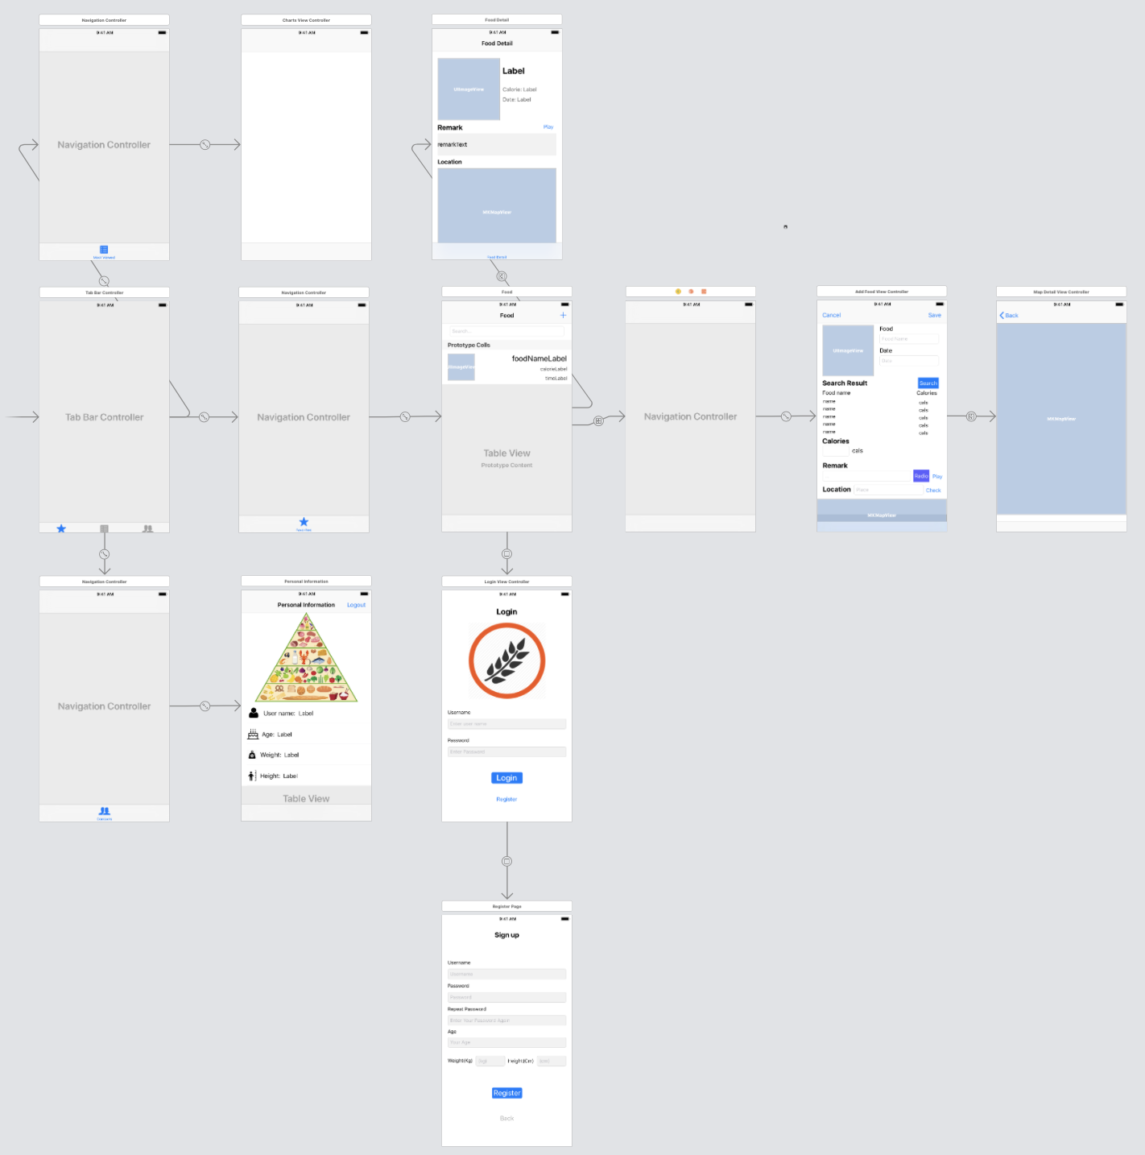

# Structure of database tables

For Record core data tables

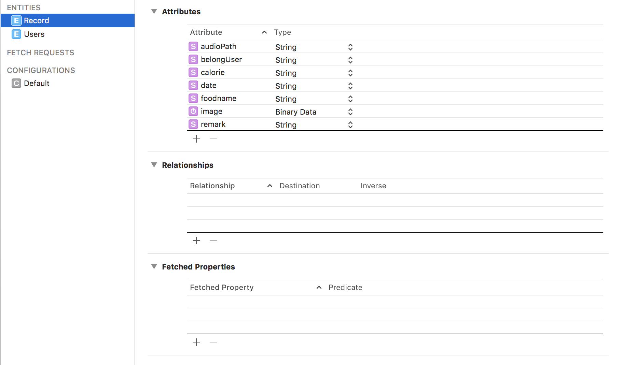

For Login account core data tables

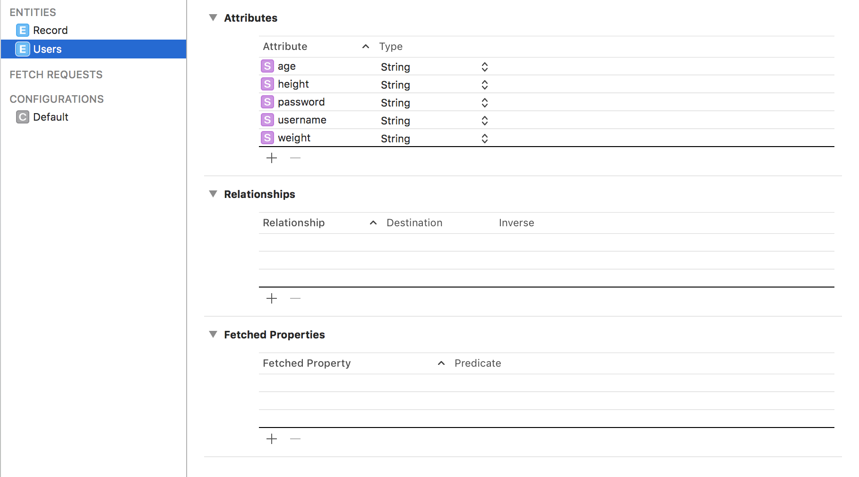

# User Guide run(Capture screen)

# Function

Account

* **Register**

Public user need provides their username, password to register to be a customer, which can conveniently and offer to record and calculate of the result.

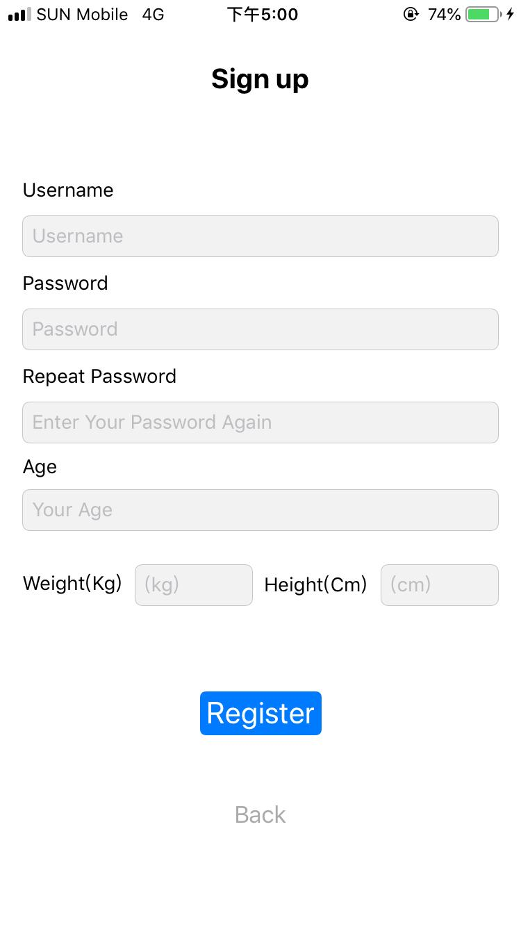

Firstly, the user needs to do a registration(Enter username, password, repeat password, age, weight, height)

* **Login**

The user can save their record and record their amount of exercise.

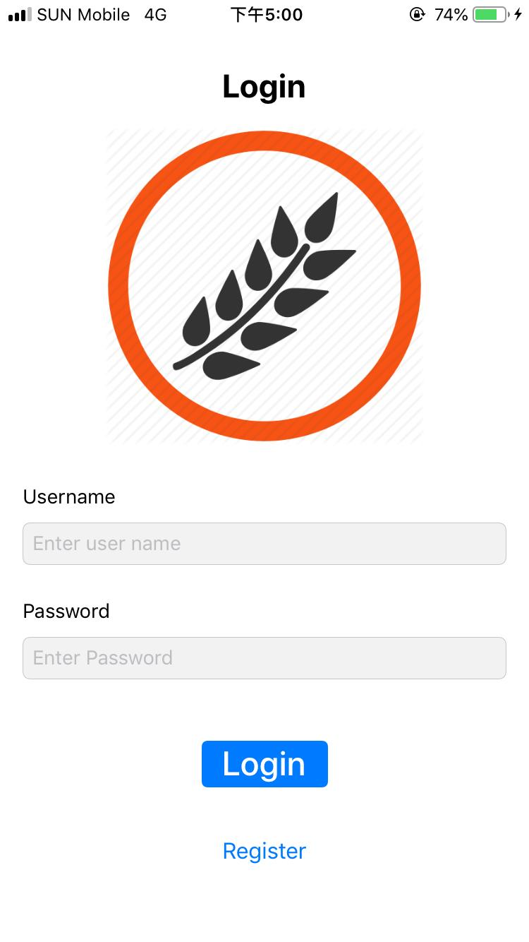

* Review personal profile

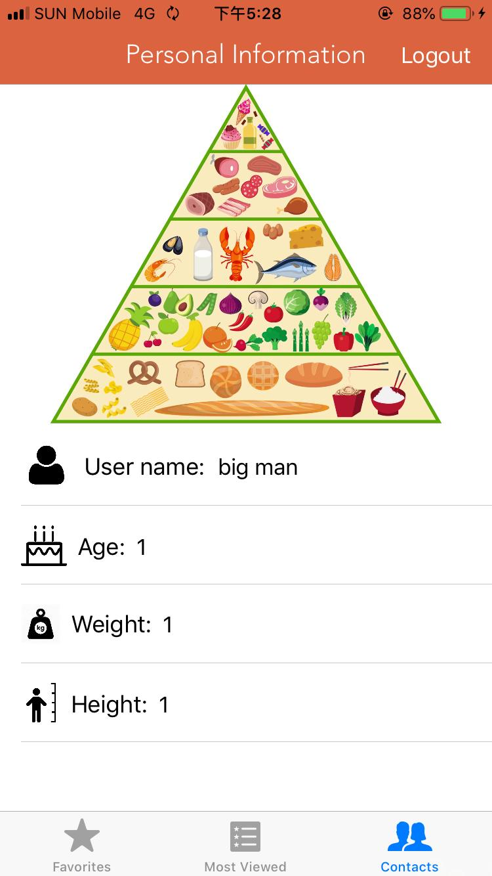



Logout to protect personal information

* **Single Login**

When the users log in the system. Login with the account password. Also, the login offers a single login function. It simplifying the process of the user login.

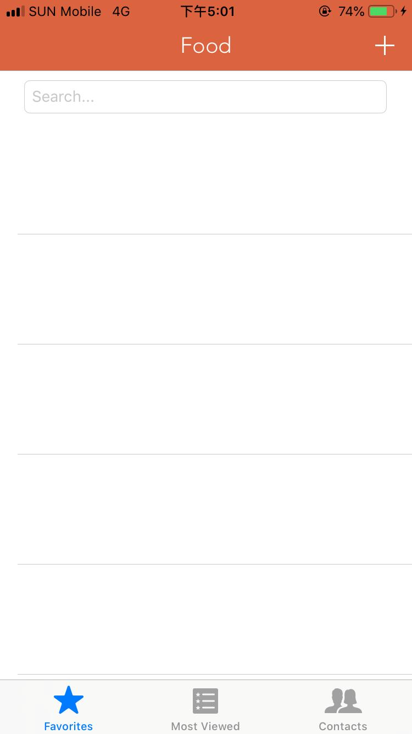 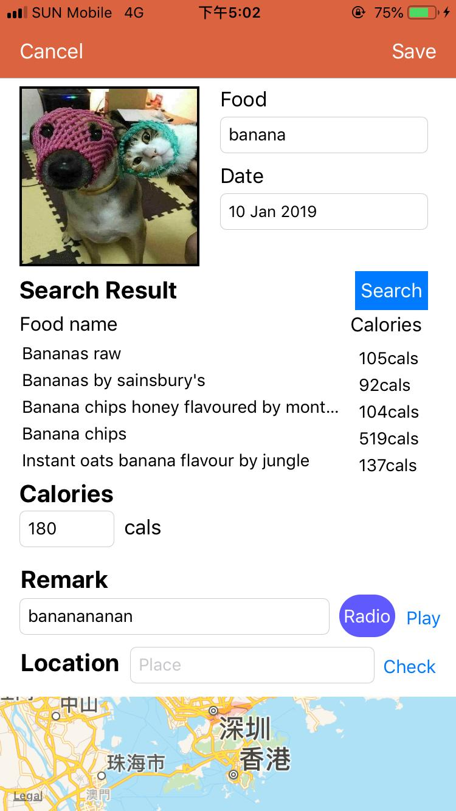 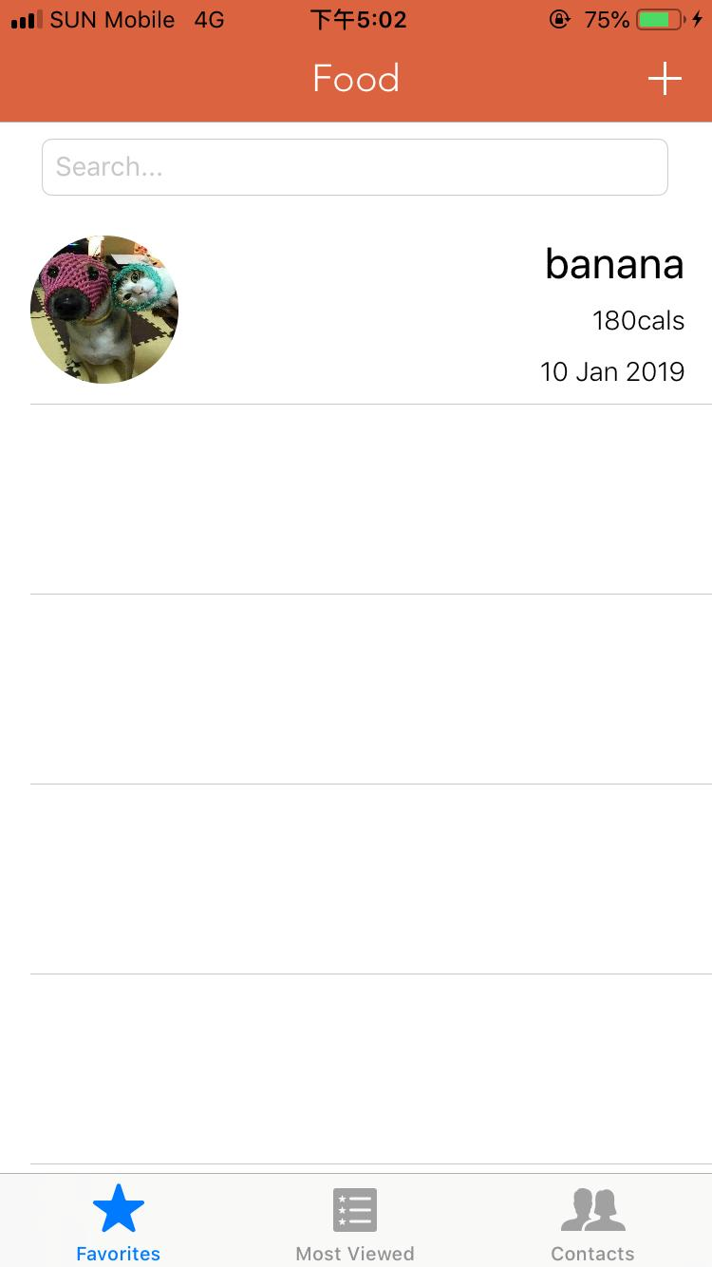

Add Data

* **Table Way**

The user can type the data they need in the table.

* **Record voice note**

The voice record provides another choice to store the related food information if the customer doesn’t want to type the data. they can use the voice record function to record the record of speaking.

Click + button to save a record

The record contains the following data

* Food name
* Date
* Image
* Search calorie (Show List of calorie)
* Calorie
* Remark
* Voice message note(Press Radio to Use Voice function)
* Location

Delete Data

The customer can delete the related food information they don’t want.

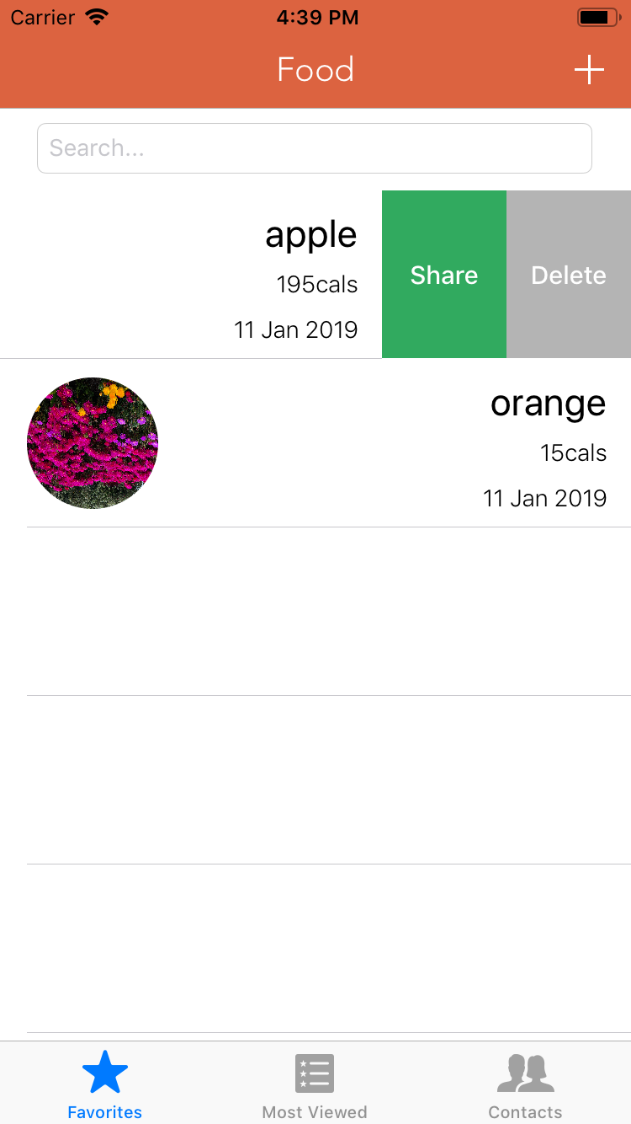

Search function

A lot of data, it makes the user confusion so the user can type the keywords searching to filter the selected data. The user can search by food name or date.

Share data Function

the customer can post the blog to Facebook, WhatsApp and google email to share their records

Mark location on Map

The customer can mark the location which tells herself the food of place of origin or which location they ate the foods.

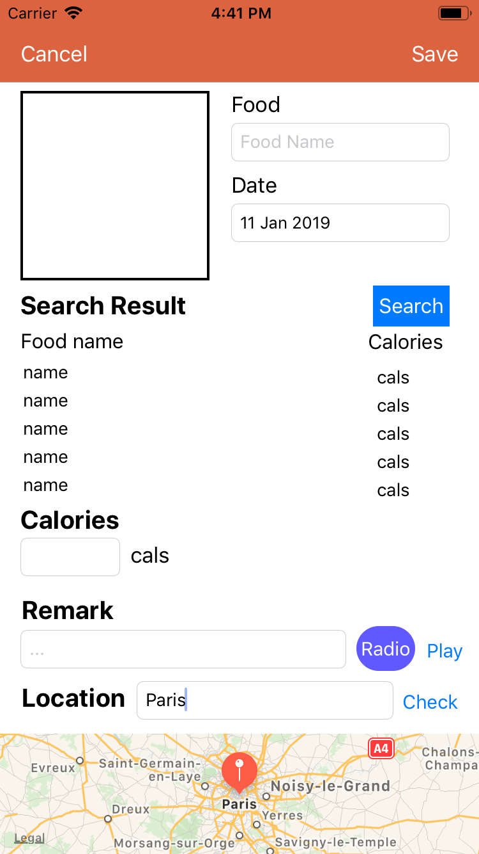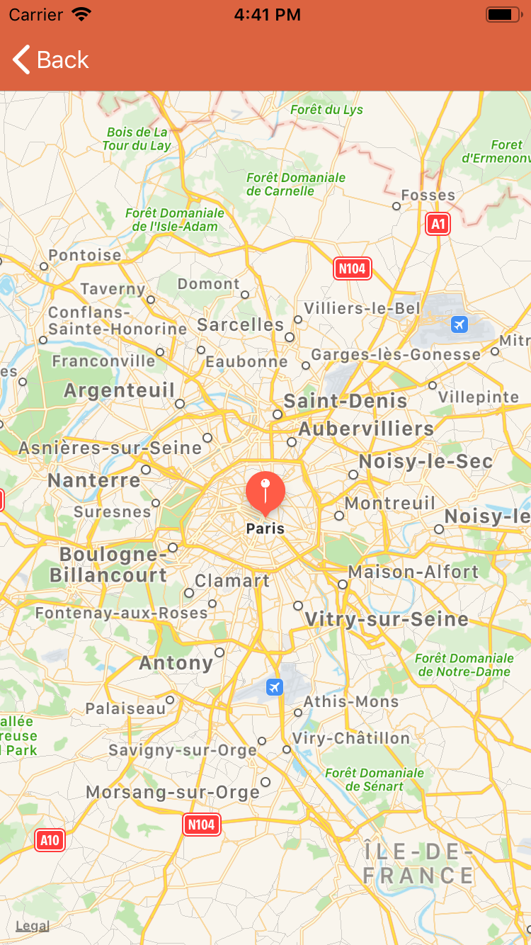

Fig.10 find location to save Fig.11 show location

Calorie Analysis

The app would collect the user related information which includes the height, weight, age, and their intake calorie of every day. it will be calculated by the particular calorie formulates and return analysis result for the user, it helps the user to notice their health status.

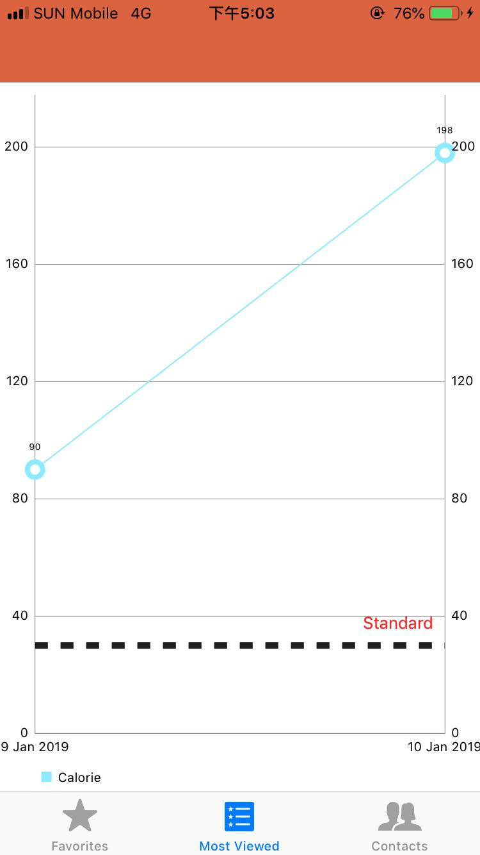

Click line chart button to show calorie intake and suggest intakes.

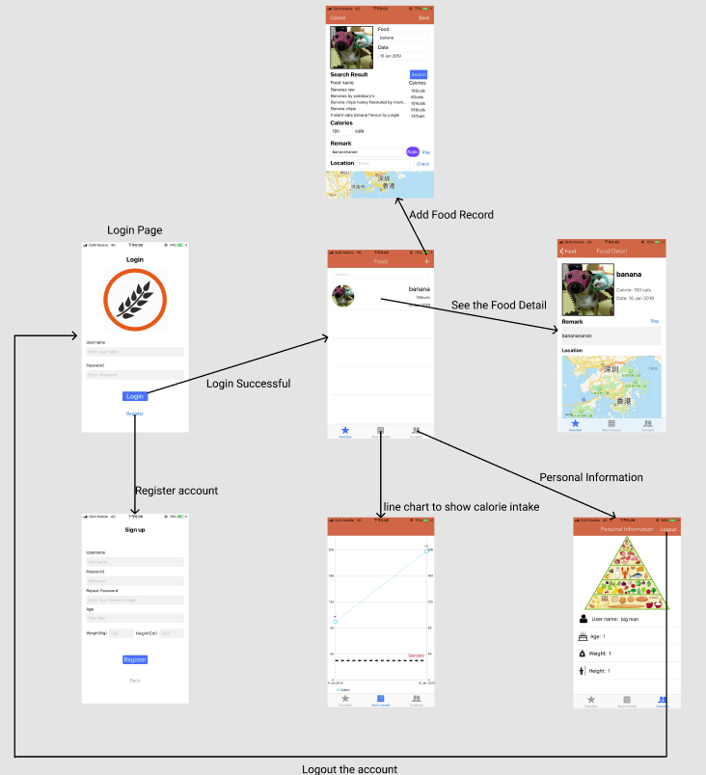

# Conclusion and Further development

1. Build a picture identify the function to find out the food name and calories.
2. Record user‘s physical activities to calculate a more suitable calories intake for controlling a health problem
3. Improve UI experience, for example, add a calendar inside the table view to classify every day clearly
4. Use Database replace coredata to save the data such as Login Account, Calories record, and Image
5. Use other platforms to login and register the account such as use google, facebook, Instagram

# References

Swift 4.2

https://swift.org/

Charts(API)

https://github.com/danielgindi/Charts

ITP4206_IT_ICT_kwokyuho_1

Lab 1 - Lab 10